HOW TO UP DATE FIRMWARE- VOICE GUIDANCE MUTE

Format micro SD card using the H50 DVR, after formatting the card remove it from the H50 and put it in you computer usb using the USB adaptor provided in the box. Open up the micro SD removable disk in your computer. Down load the blackbox_h50.rom and copy paste in the thinkware card and it should look like this.
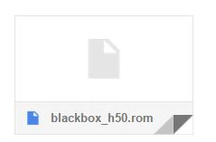
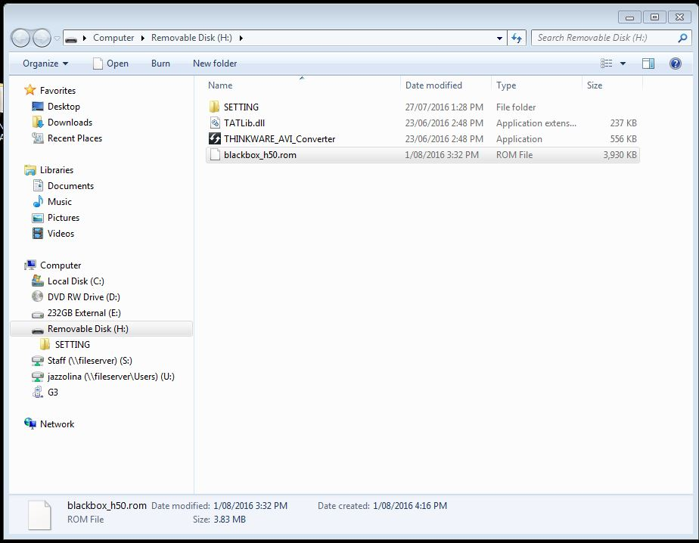

Once completed pasting the ROM file, remove the card and insert it in the H50, turn on the H50 and a message will say it's going to update date firmware, this might take up to 30 sec to 1 Min to finish straight after you will hear a message completed update. Turn off the H50 remove the card and inserted back on to your computer, open up the H50 Pc Viewer wait until the program registers the card, click on the settings.
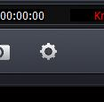

When in the settings make sure the voice guidance is not ticked, save the settings, remove the card and insert it back in the H50, turn the device on this should have muted the voice guidance.
