PHILIPS CED780 software release
Issue date :2012-01-14
Purpose
Firmware upgrade the new features which describe on the documents SW change history
Firmware upgrade Files
1. sy_w5@01: This file is for upgrade the section of ARM .
2. 780@@MCU: This file is for upgrade main system..
3. dvdrom. Bin: This file is for upgrade DVD section

Following on the below step for upgrade;

A.How to upgrade main system software
- Extract “sy_w5@01.rar” file ,you will see “sy_w5@01” folder
- Copy all “sy_w5@01” folder into a TF CARD（Micro SD）
ARM UPGRADE：
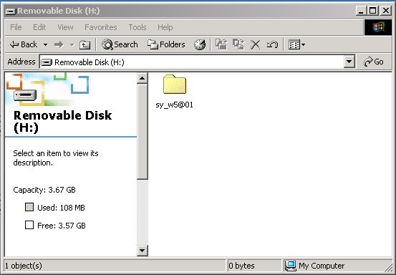
Important: The card must remove all the content (Files).Only keep “sy_w5@01” folder
in the Card. If there is another files inside, the upgrade system is cannot process normally

- Insert the card into CARD SLOT of CED780 unit

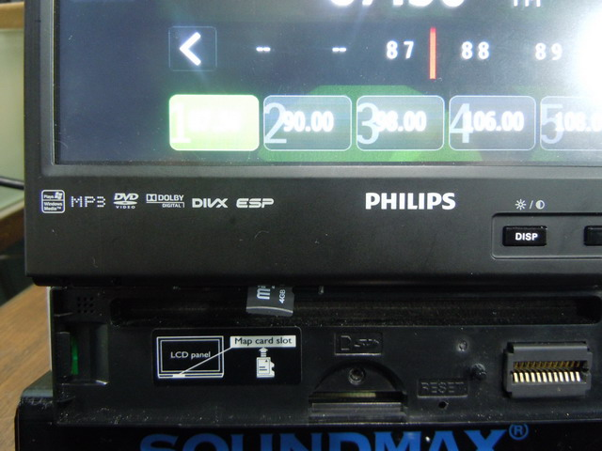

- POWER OFF unit, then power on.Unit automatically upgrade ARM

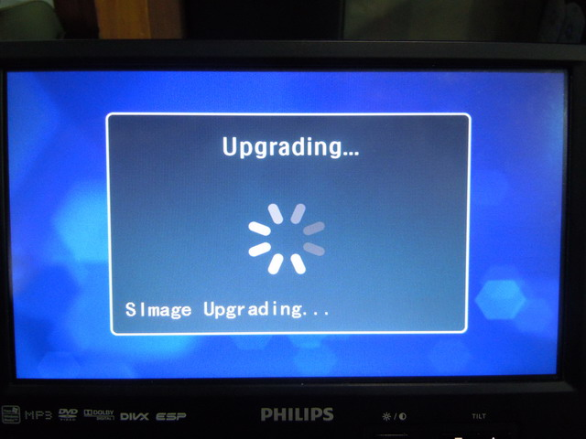

3、if unit TFT always show “Simage loading. Wait 5 seconds! ”,you may power off unit ,power on CED780 unit again.
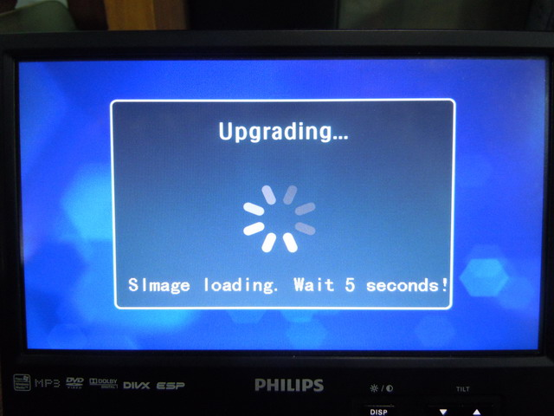

4.Once ARM upgrade successfully, CED780 TFT will show “upgrade ok”.This moment can take out card from card solt. To make sure the software fully initialize the main system. This is highly recommand to re-start the main power of this unit once again

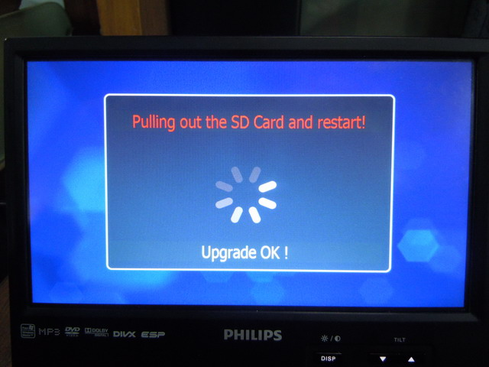

B.How to upgrade main system software MCU UPGRADE：
1.Extract “MCU.rar” file ,you will see “780@@MCU” folder
2. Copy all “780@@MCU” folder into a TF CARD（Micro SD）
3.Insert the card into CARD SLOT of CED780 unit

Important: The card must remove all the content (Files).Only keep “780@@MCU” folder
in the Card. If there is another files inside, the upgrade system is cannot process normally

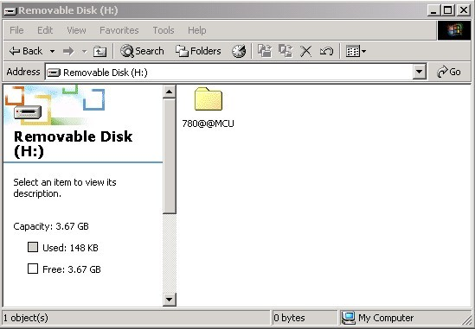
4.POWER OFF unit, then power on.CED780 TFT display show “do you want to upgrade MCU”
Tap YES to confirm software upgrade
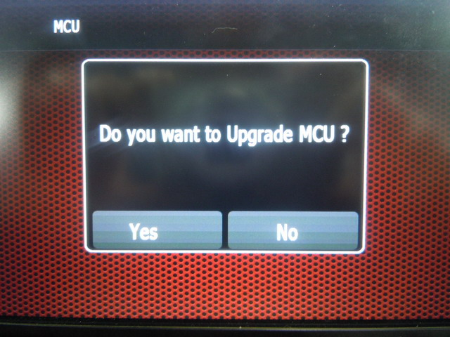

- Unit is under software upgrade process.when unit TFT show“OK”， CED780 will restart. This moment can take out the card,then main system upgrade successfully.
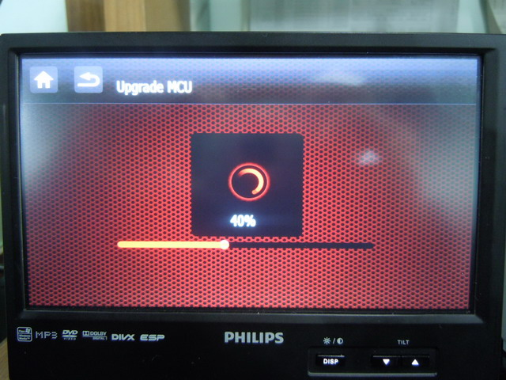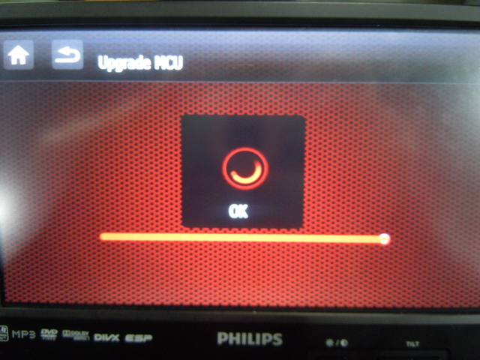

C.How to upgrade DVD software DVD UPGRADE:
1.Extract “dvdrom. rar” file ,you will see “dvdrom. bin” file
2. Copy the “dvdrom. bin” file into a USB device
Important: The USB device must remove all the content (Files) because the upgrade is only recognize one file in the USB device. If there is another files, the upgrade system is cannot process normally
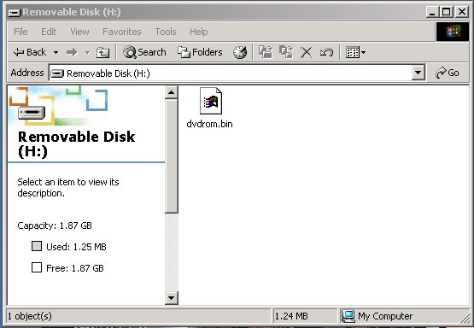
3.Insert the usb device into USB port of CED780 unit

4.when CED780 unit detect the software in the USB device,it automatically upgrade,no need any operation

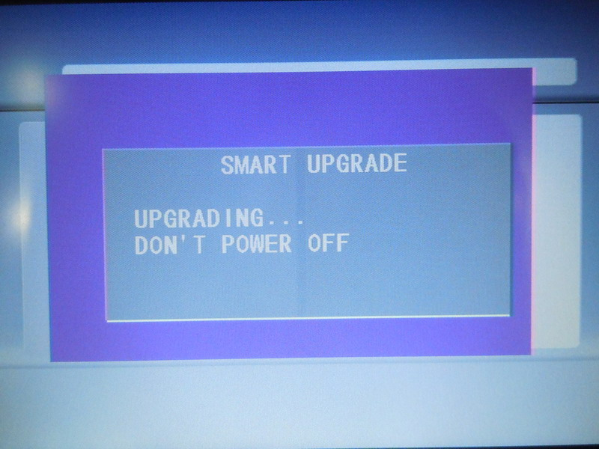

Important: during DVD software upgrade, please be reminder that don’t make any operation.You cannot cut power supply, power off/on unit or change mode etc.

5.if DVD software upgrade sucessfully,CED780 TFT will always show PHILIPS logo. This moment can take out USB device.To make sure the software fully initialize the main system. This is highly recommand to re-start the main power of this unit once again
