HOW TO INSERT THE BATTERY IN THE REMOTE THE CORRECT WAY

THIS IS NOT THE CORRECT WAY TO INSERT THE BATTERY

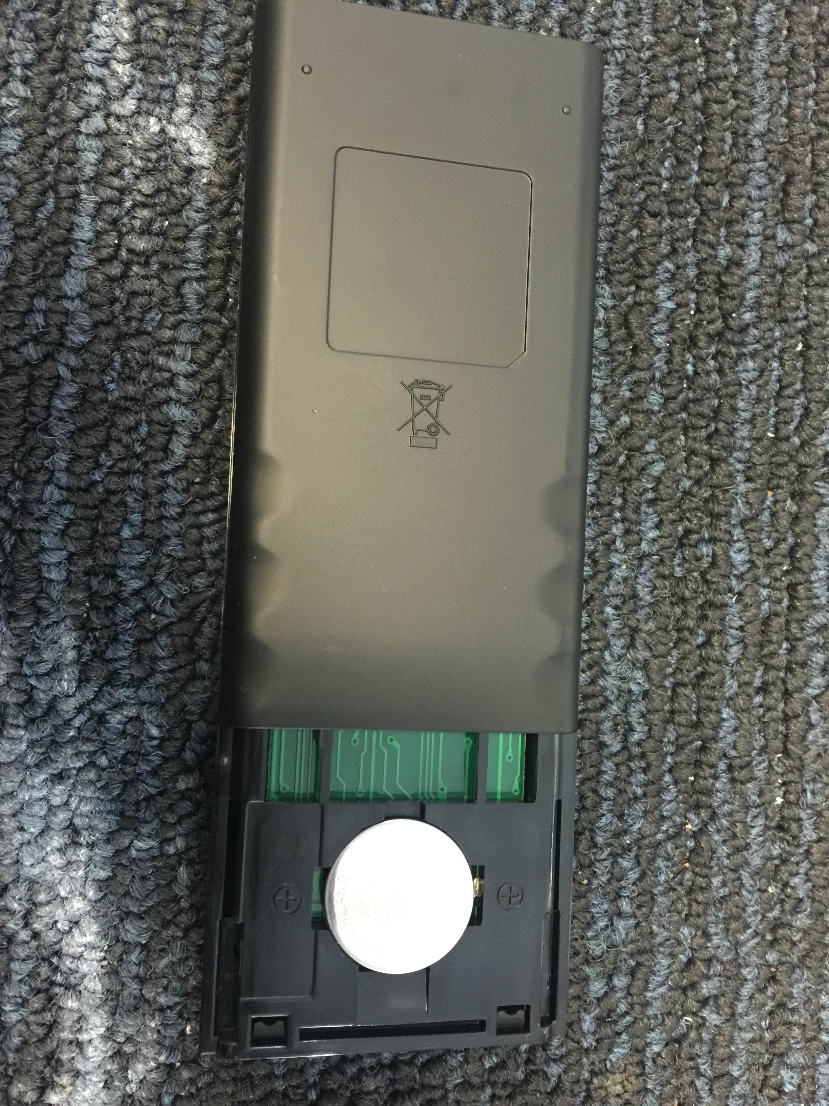

MAKE SURE THE BATTERY TAB IS LIFTED, INSERT THE BUTTON BATTERY UNDER THE TAB
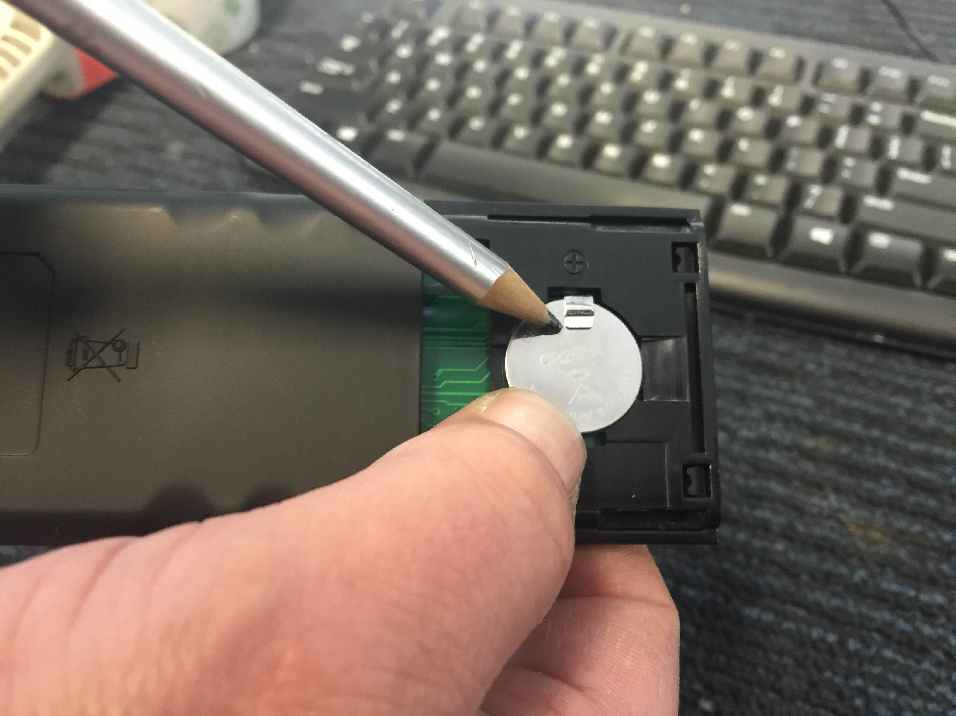

HOLD BATTERY DOWN AND INSERT THE COVER

