Play SW Instruction
Installation instructions:
（1） Install software
Please install the software in the CD：QuickTimeInstaller.exe
（2） Copy the software to the PC
Please copy the folder“cardv_r”to PC
（3） Use play software
Double click “CARDVC2” under the folder “cardv_r”.
（4）click the red circle in the picture below to choose the video files.
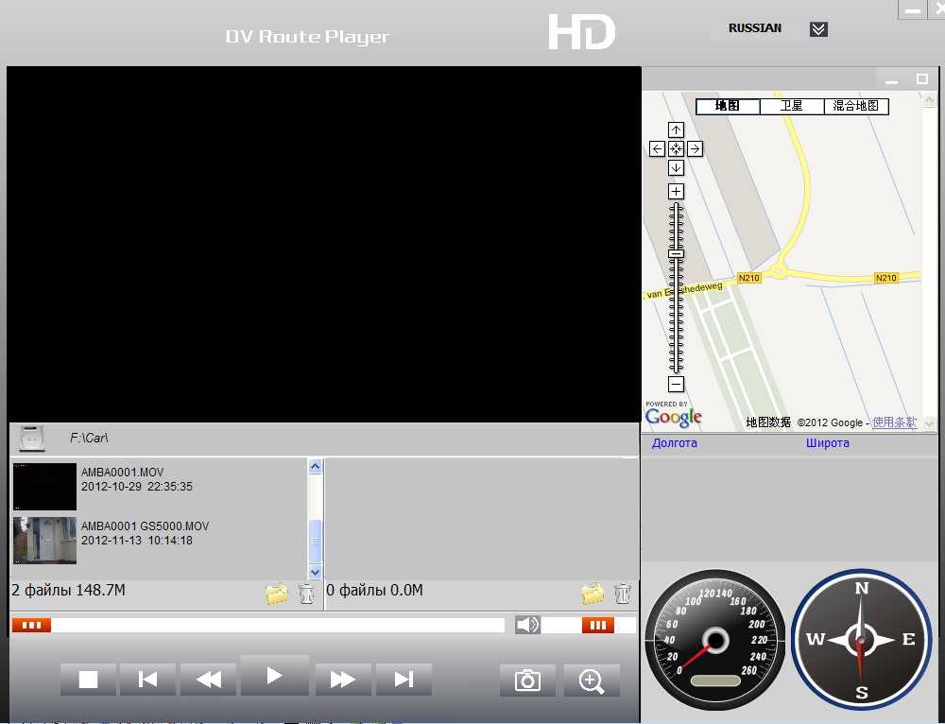
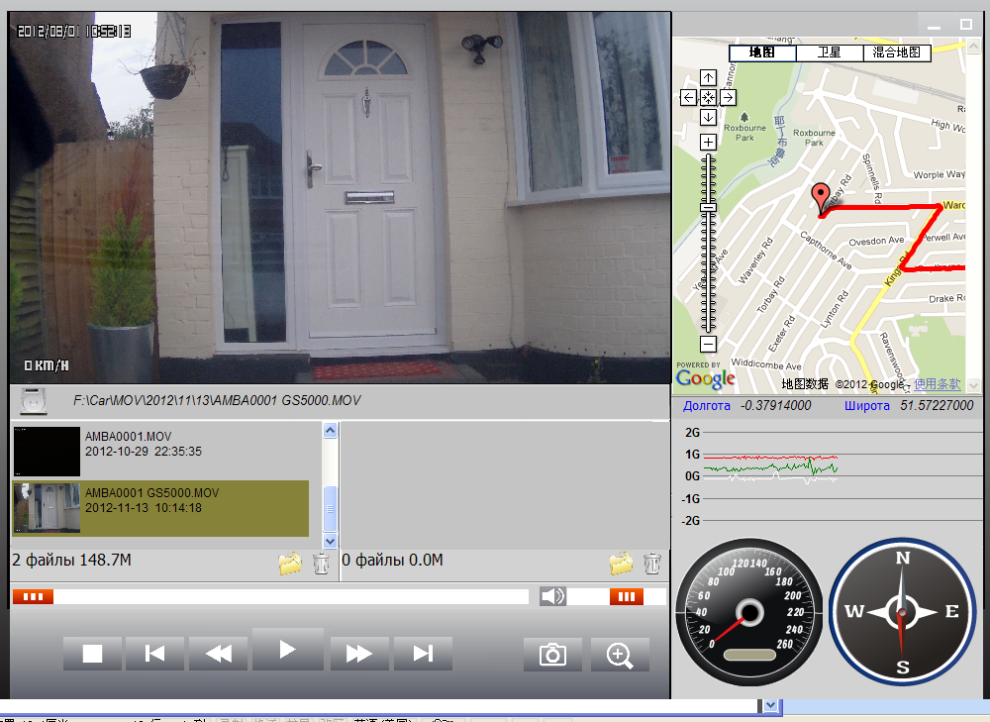
Choose video here
Click here to play
DisplayArea of map

