Table of Contents

1. Gateway Lite BT 4
A. How to set text display on BMW: 5
B. How to get / generate the GW_EES.BIN file: 7
C.Is there any track limit? Is there any recommendation for how to organize my music? 8
D. What is the free brown cable on the Gateway car harness? 8
E. Where to connect the mute wire on the radio 8
F. What is the free black cable on the Gateway car harness? 8
G. The Gateway Lite (GWLxxx, GBLxxx) volume is distorted / lower than my Radio or CD player. Is there any option to change the volume output levels? 8
H. The Gateway Lite BT iPod / iPhone /iPad compatibility 9
I. iPod / iPhone not recognized 9
J. USB compatibility 10
K. USB does not work / Gateway does not see the connected device: 10
L. Phone compatibility 11
M. Phone issues 11
N. No sound only control on BMW 11
O. Other issues (Gateway is not recognized, Alternator noise) 12
P. Firmware update 12
Q. Specific BMW issues (volume changing, CDC cannot be selected) 13
R. Phone pairing procedure takes too long 13
2. iGateway 14
A. iGateway iPod / iPhone /iPad compatibility 15
B. iPod / iPhone not recognized 15
C. There is no Text: 15
D. No sound only control on BMW 16
E. Factory phone sound does not audible (no sound) 17
F. No sound from Navigation or phone (wires repopulation on BMW 17 PIN) 17
G. Firmware update 18
H. Specific BMW issues (volume changing, CDC cannot be selected) 18
I. Activation on VW (Volkswagen CAN BAP – GW17V21) 19
j. Volume is distorted or low compare to other sources 19
3. Gateway Pro BT support issues 20
A. Gateway Pro BT iPod / iPhone / iPad compatibility 21
B. iPod / iPhone not recognized 21
C. USB compatibility 21
D. Phonebook content is not visible 22
E. There is no sound from iPod / iPhone and/or USB 22
F. Factory phone option does not work 23
G. A2DP function is not available in the Source menu 23
H. CDC not removed properly (CD-Changer is there on iBus) 24
I. Original phone is connected 24
J. Activation on VW – Median and Phone (GWP1V21) 24
K. How to get / generate the GW_EES.BIN file: 25
L. Volume issues 26
M. Audi with different steering wheel buttons 26
N. There is no Phone menu on Audi 27
O. DIP switches 27
4. Gateway 500 (GW51MO2) support issues 28
A. IPod / iPhone / iPad compatibility 29
B. USB compatibility 29
C. USB does not work: 29
D. Firmware update: 29
E. Alternator noise via AUX: 30
F. Volume issues: 30
G: Installation / Programming issues: 31
H: GW51MBE issues: 35
5. Gateway 500S BT (GW52MO2) support issues 37
A. Differerences between the GW500 (GW51MO2) and the GW500S BT (GW52MO2) 38
B. Gateway Pro BT iPod / iPhone \ iPad compatibility 38
C. USB compatibility 39
D. USB does not work: 39
E. Firmware update: 39
F. Volume issues 40
G. Installation / Programming issues: 40
H: Places of the factory CD-Changers and Factory phones: 40
6. Gateway 500 Lite support issues 42
A. Differerences between the GW500 (GW51MO2) and the GW500S BT (GW52MO2) 43
B. IPod / iPhone / iPad compatibility 43
C. USB compatibility 43
D. USB does not work: 43
E. Firmware update: 44
G. Installation / Programming issues: 44
7. Gateway 500 Lite D2B support issues 45
A. Differences between D2B and MOST 46
B. IPod / iPhone / iPad compatibility 46
C. USB compatibility 46
D. USB does not work: 46
E. Firmware update: 47
G. Installation issues: 47

Troubleshoot guide

Gateway Lite BT

- No ID3 display on BMW (how to set radio to display text)
- How to capture GW_EES.BIN
- Is there any track limit
- What do I do with the loose brown wire in harness
- Where to connect the mute wire on the radio
- What do I do with the loose black wire in harness
- Volume issues
- iPod / iPhone / iPad compatibility
- iPod / iPhone not recognized
- USB compatibility
- USB does not work
- Phone compatibility
- Phone issues
- No sound on BMW (only control)
- Other issues (Gateway is not recognized, Alternator noise)
- Updating firmware
- Specific BMW issues (Volume changing, CDC cannot be selected)
- Phone pairing procedure is taking an excessive period of time

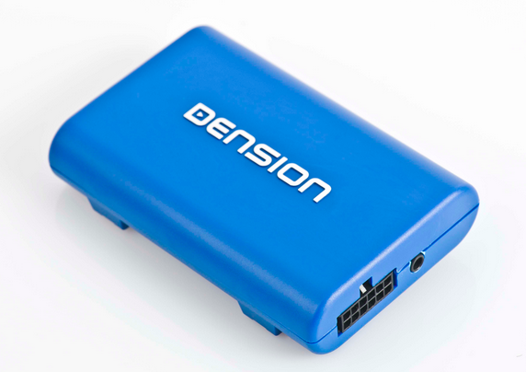

A. How to set text display on BMW:
Please note: The Gateway Lite BT is only capable of displaying text on BMW radios because

- Gateway Lite BT is not capable of full menu browsing, you will only have song information display
- There is 3 different display types available (Radio; MID and Navigation) and each requires a different configuration, so you will need to change settings after installation

To set text from the text selection menu, you must do the following:

- Turn the Radio ON and select the Gateway (CD-Changer option)
- Disconnect all devices from the Gateway and wait until CD5 / Track99 is displayed on the radio
- Keep the FF (Fast Forward) button pressed for longer than 10 seconds, then release. The display turns to Disc 1, Track 01 within three seconds (Text selector mode)
- The display will change to Disc 1 / track 01 within 3 seconds (this indicates you are in text selection mode)
- By pressing the Next track button, you can toggle between Tracks 02-04 which set different screen modes (e.g. MID, Radio). Please note: Track 01 is the non-Text Mode
- When you have moved the text to the position you prefer, press FF (Fast Forward) to confirm. Or, by pressing the REW (Rewind) you can exit Text selector without making any changes
- If the text selection procedure was correct AUX GW will appear on the display
- If the text selection did not come up, try again from step #3 and try another track option. Some radios will need to be set to a specific track to operate properly.
Please note: If selections of track 2-4 fail to display text, it could be that the radio does not support text for one of the following reasons:
- The radio is manufactured by Becker and therefore will not support text (That information is available at the tuner, there is no info on the radio)
- The Head Unit has a phone module or preparation. This cause an issue on Business radio

On some BMW radios, there is an “M” button between the Next Track and Previous Track buttons that changes the function to FF (Fast Forward) and REW (Rewind).

On these radios, it is necessary to the “M” button for the text activation procedure

- Turn the Radio ON and select the Gateway (CD-Changer option)
- Disconnect all devices from the Gateway and wait until CD5 / Track99 is displayed on the radio
- Press the “M” button on the radio an “M” should show on the radio display
- Keep the FF (Fast Forward) button pressed for longer than 10 seconds, then release. The display turns to Disc 1, Track 01 within three seconds (Text selector mode)
- The display will change to Disc 1 / track 01 within 3 seconds (this indicates you are in text selection mode)
- Press the “M” button on the radio to select Next / Back function
- By pressing the Next track button, you can toggle between Tracks 02-04 which set different screen modes (e.g. MID, Radio). Please note: Track 01 is the non-Text Mode
- When you have moved the text to the position you prefer, press “M” then press FF (Fast Forward) to confirm the track selection. Or, by the REW (Rewind) you can exit Text selector without making any changes
- If the text selection procedure was correct AUX GW will appear on the display
- If the text selection did not come up, try again from step #3 and try another track option. Some radios will need to be set to a specific track to operate properly.

B. How to get / generate the GW_EES.BIN file:
Getting a GW_EES.BIN file sometimes it is very useful because we can see
- what is the exact firmware version
- what are the basic settings (text, or car configuration)
- we can see if device is connected (like BTA1500)
The process of getting that file is very easy. You need to have a simple USB thumb drive which is
- formatted to FAT 16/32
- has only one partition
- there is one playable music content on it (it is no problem if other files are there too)
You need to do (ask from the customer / installer) the following
- Power the system ON (radio, ignition)
- Connect the USB to the Gateway (it will start flickering)
- Select the Gateway as a source
- Turn the whole system OFF, remove the car key too
- Wait about 1 or maximum 2 minutes then
- Turn the system ON again (e.g. radio)
- The USB will start flickering
- Wait 10 seconds, disconnect and check the content on a PC. The GW_EES.BIN should be on it
Please note: If the file is not available, then please ask them to use a different USB stick and repeat the mentioned steps above.
The firmware version can be checked if you open that file with WordPad. If you click on view, you will see the following:

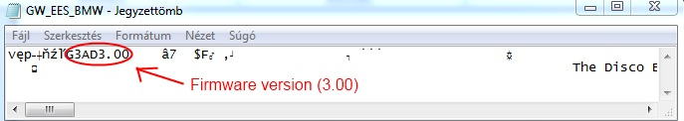

In this case, the hardware has firmware version 3.00. Please check if there is newer firmware available for download. If yes: You need to always recommend that (!).

C. Is there any track limit? Is there any recommendation for how to organize my music?
There is no limit referring to track numbers. You can have as many as you want if the overall size of your music not larger than the maximum capacity (256 GB) that we offer.

The Lite BT is a non-text capable device (except BMW where id3 tags can be displayed) so personally I would not use USB drives which are bigger than 64 GB, because it is simply difficult to search the music, that I want to listen to.

The recommended structure of the music is Genre (Pop, Techno) and Artist or Album.

D. What is the free brown cable on the Gateway car harness?

The free brown lead on the Gateway car harness needs to be connected to the phone mute pin of the car radio. This cable is responsible to mute periodically the actual played media when Radio or simple CD-mode selected.

Please note: There is no free brown lead on BMW (GBL3BM1/BM4)

E. Where to connect the mute wire on the radio

The separate brown cable (except BMW) needs to be connected to the Phone mute pin of the radio.
The position of that PIN is different in every radio, therefore they need to check the Pin out diagram of the radio. When they remove it from the Dashboard, there must be a draw on the radio. If not the only quick solution is to “google” it. Of course if any problem / question arise, we can help but takes a little bit of time.

F. What is the free black cable on the Gateway car harness?

The free black lead on the Gateway harness must be grounded / connected to the chassis of the radio. In case of BMW you don’t need to connect this lead.

If this cable is not connected on Audi or VW, then the Gateway won’t work at all (!).

G. The Gateway Lite (GWLxxx, GBLxxx) volume is distorted / lower than my Radio or CD player. Is there any option to change the volume output levels?

This could happen “relatively” easily because all car/ chassis are different. It can be small, medium, big or large like a stadium, could come with 4 speakers or 12 speakers…… All in all we use default settings which works in most cases but sometimes not. If not: It can be too loud, distorted or low compare to other sources. If the installer / customer is having the same problem, then you need to recommend them to go to the Dension website and download the volume configuration files and read the specific Knowledgebase article:

http://www.dension.com/knowledge-base/the-gateway-lite-gwlxxx-gblxxx-volume-is-distorted-lower-than-my-radio-or-cd-player-0

The appropriate steps are the following

Follow the steps below:

  - Unzip the volume package file
  - Select and copy the appropriate configuration file from iPod, USB or AUX & A2DP folder to the root of a USB flash drive where you have at least one playable content. Use 0dB / +6dB files if the volume is lower or -1dB/-20bB if the volume is distorted
  - Connect the USB drive to the Gateway while it is powered up
  - The volume configuration procedure takes about 2 seconds. When finished, the next song will be audible on your car’s speakers
  - Turn the Audio System OFF, remove the ignition key and wait about 20 seconds. Turn the Audio System back ON
  - Test your Audio System. If the volume output is still not optimal, please repeat steps 2-5 with different volume configuration file

Please note: Although we do support playing music content from a USB hard disk drive, for the firmware update please use a USB flash stick/pen drive.

H. The Gateway Lite BT iPod / iPhone /iPad compatibility

- iPod (4th generation)
- iPod nano (1st, 2nd, 3rd, 4th , 5th and 6 th gen.)
- iPod mini
- iPod Photo 4G
- iPod Video 5G
- iPod Classic (80/120/160GB)
- iPod Touch (1st, 2nd, 3rd and 4th generation)
- iPhone, iPhone 3G / 3 GS & iPhone 4 / 4S
- iPhone 5, iPod Touch 5th and nano 7th supported via Lightning to 30 pin adapter

Please note: The new Apple devices with Lightning connector will not be supported via USB (!)

iPad: iPad is only works if iPod UI (Simple remote) mode is selected. Charging available on iPad 1st generation. Newer models require 2A of charging what we can’t provide.

I. iPod / iPhone not recognized
This usually happens if there is a problem with the iPod / iPhone or Dock cable. Before replacing anything, you need to try the following:
- Make sure that is has music on it
- Reboot the Apple device (if the Apple stuff is iPhone, close all apps too before the reboot)
- Update the iPod / I Phone if newer available
- Check the charging status. If there is no charging than the problem is bigger, might be installation related (no ground cable connected on VW / Audi)
- Test the system with different Apple product
- Disconnect and reconnect the hardware from the power
- Check the Dension website. There might be a specific update for the Gateway

J. USB compatibility

Flash Memory and Hard Disk Drive
File system: FAT16/32
Storage capacity: up to 250 GB music content
Music format: MP3, WMA and WAV

Please always recommend branded USB drives like Kingston, Sandisk, Transcend etc.

K. USB does not work / Gateway does not see the connected device:

In some cases when the customer / installer plugs the USB thumb drive to the USB socket of the Gateway Lite BT it will only continuously flash or just flashes once (will not play audio).

When USB is connected to Gateway, it starts to index the content immediately (LED on the USB is blinking constantly) in order to find and select the tracks as quickly as it possible. If large music content is connected (4GB or above) that may take minutes during which the USB cannot be accessed properly, so Playback is might not be available, or it may happen when the user changes the music content on the USB and the Gateway cannot find the previously indexed songs.

So, if there is a problem with the USB playback, in that case I recommend to do the following:
- Wait approximately 1-2 minutes, then the playback should start
- Turn the system OFF, remove the car key too , wait 1 minute, and turn the system back ON and the playback should start immediately
- Delete all bin files from the USB stick’s root (those are index files and might be damaged)
- Download Gateway Indexer software (works under windows) from our website. It does the exactly same job as the Gateway, but faster
If nothing helps then you need to get some details from the USB stick, regarding to
- Size (we are fine up to 250 GB)
- Brand (cheap sticks are not very well supported due to the very bad memory chip on board)
- File system (only FAT16 & FAT32 supported)
- Partition which needs to be only one (!). Some USB comes with free backup and other option which uses separate partition, which could cause easily the recognition fail
- Ask if they are using any aftermarket extension cable
- Ask them to try the system with another USB device with only a few files loaded to it

L. Phone compatibility

We are constantly working to extend our compatibility chart however there are still so many which are still untested. In overall since our new BT devices have been revealed with the latest BT chip on board, I can say that we are working fine with most of the phones (e.g. iOS, Android, Blackberry, Bada). There are some very specific local phones from Verizon or AT&T what we were never be able to test. If you have any feedback for such a phone which works fine, please share that info (!)

The current chart can be downloaded from http://www.dension.com/compatibility

M. Phone issues

The Gateway Lite offers HFP and A2DP features altogether. Due to the missing TEXT option, there will be no text information at all on the screen if you have an incoming or outgoing call.

We don’t have too many complaints just a few frequently asked questions

- Microphone volume is low: press the next track button during the phone call, which lets you to browse between 10 different volume values (different beep will be audible via the speakers during the volume setup process) . If you find the optimal sound level, you can leave it in that position and it will be saved automatically after the conversation

- Phone does not connect: In rare cases, the phone cannot be paired easily to the Gateway Lite BT device. In such cases, please ask to turn the BT option OFF on the phone, reboot it and try again. If still no luck, please disconnect and reconnect the Gateway Lite BT from power. If no progress, please check if newer firmware is available for the Gateway Lite BT and / or the phone (!). Additionally testing another phone is highly recommended to find out if the problem is related to one specific phone or not

- A2DP volume: This volume can be changed in a similar way as the other source outputs, like iPod, USB . The customer needs to download the volume configuration files from our website and change default settings via USB thumb drive

N. No sound only control on BMW

This problem could appear on 2 specific cases

- The car has DSP
- The CD-Changer plug has been connected in a wrong way on GBL3BM1 (17 PIN or it is also known as Round PIN connector)

DSP: If the car has DSP, the application is not compatible, due to limitations of the Gateway device. DSP systems require a digital input but the Gateway provides analogue so in those cases there will be no sound, only control. Having a DSP option is rare, there is no label on the radio. You can tell if you check the Tuner. If you see a coax connector, then it must be a DSP based system

CD-changer plug: The CD-Changer plug is a separate cable (comes with the 17 PIN plug) which ends on a 10 pin white “molex” connector. This cable can accidently be connected in 2 ways to the Head Unit’s CD-Changer port. If the radio sees the Gateway but there is no sound, it could be sign of improper installation. Ask the installer to rotate it by 180° and plug back in.

O. Other issues (Gateway is not recognized, Alternator noise)

Gateway is not recognized: This could happen if the ground cable is not connected (in case of VW or Audi) or the installation is incorrect (bit difficult to do it wrong but….. happens). It can also happen to the cable is damaged causing the car configuration resistor to be faulty (making it default to BMW)

Alternator noise: This is an extremely rare problem. If it happens, it means there is an issue with the cable or the hardware. Replacing the whole package (HW and car harness) is necessary.

P. Firmware update

We constantly improve our firmware therefore it is highly recommended to perform a firmware update first, if any issue / problem arise. The update procedure on devices that have USB is simple.
Extract the G3AG_UPD.ROM file from the update package and copy it to the root of a USB flash drive, then connect the USB drive to the Gateway Lite while it is powered up.
If there is an iPod connected to the Gateway Lite you can leave as it is, in any playback mode or status, you do not need to disconnect or stop playback.

Update procedure will start automatically within a few seconds and takes approximately 1 minute. Do not disconnect the USB drive within this time. During the update the head unit (car stereo) turns to tuner mode and the Gateway restarts.

When finished, change the source to CD-Changer to use the Gateway Lite again.

After a successful update G3AG_UPD.ROM is deleted from the USB flash drive and
GW_EES.BIN file will appear with the new software version.

If the firmware update was not successful, that means:

- The USB had no music content, therefore the Gateway Lite BT did not recognize it
- The USB stick had more than one partition
- The USB stick was formatted to NTFS or to a format other than FAT16/32
- The Gateway Lite BT device has this update already -> check the GW_EES.BIN

If the device is not functional after the update: (This usually happens if the user disconnects the USB during the update process or the power has been removed during the update)

- Downgrade to the previous version
- Disconnect and reconnect the device from power
- Check the system. If one function works (USB, BT, iPod) ask them for the GW_EES.BIN and send it to us. Likely something went very bad but we need to know exactly what happened

Q. Specific BMW issues (volume changing, CDC cannot be selected)

On BMW, it happens quite often that they forget to disconnect the original CD-Changer properly. Please note: The installer needs to disconnect all cables physically at the CD-Changer (2 separate wires), otherwise they will experience strange issues like:

- Volume changing automatically / randomly within 10-15 seconds or more
- CD-Changer as a source can or cannot be selected but it reverts you back automatically to radio mode (within 2-3 seconds)
- Function buttons are not or fully working (e.g. FFW)
- They cannot enter to the Text selector menu

R. Phone pairing procedure takes too long

On Gateway Lite BT, the pairing procedure sometimes requires more time than normal, which means you may need to try constantly try pairing from your phone for 2-3 minutes. This is happening because

- the hardware is ready for pairing periodically (search earlier connected phones for 30-40 seconds and search new phones for 20-25 seconds)
- If different a phone was already connected , it tries to reconnect to this phone first

If the pairing is not possible within 2-3 minutes, you can try the following steps

- Turn the radio OFF and Back ON after 20 minutes
- Turn the BT option OOFF on your cellphone and reboot and try again
- Disconnect the Gateway Lite BT from power and reconnect
- Search for available firmware updates in our website

iGateway

- iPod / iPhone / iPad compatibility
- iPod / iPhone not recognized
- There is no text
- There is no sound (BMW)
- Factory phone sound does not audible
- No sound from satellite or phone (wires repopulation on BMW 17 PIN)
- How to perform an update
- Specific BMW issues (volume changing, CDC cannot be selected)
- Activation on VW (Volkswagen CAN BAP – GW17V21)
- Volume is distorted or low compare to other sources

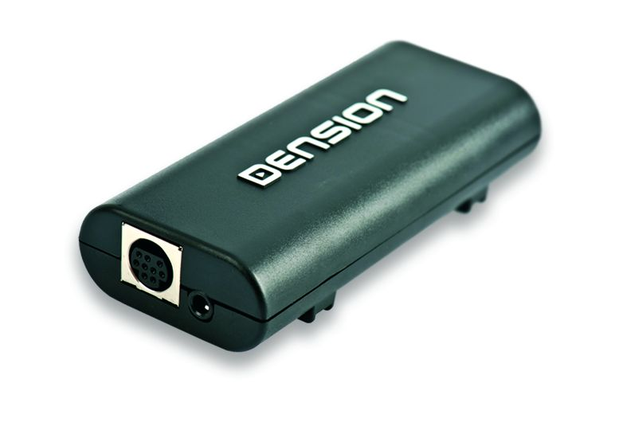

A. iGateway iPod / iPhone /iPad compatibility

- iPod (4th generation)
- iPod nano (1st, 2nd, 3rd, 4th , 5th and 6 th gen.)
- iPod mini
- iPod Photo 4G
- iPod Video 5G
- iPod Classic (80/120/160GB)
- iPod Touch (1st, 2nd, 3rd and 4th generation)
- iPhone, iPhone 3G / 3 GS & iPhone 4 / 4S
- iPhone 5, iPod Touch 5th and nano 7th supported via Lightning to 30 pin adapter

iPad: iPad is only works if iPod UI (Simple remote) mode is selected. Charging available on iPad 1st generation. Newer models require 2A of charging what we can’t provide.

B. iPod / iPhone not recognized

This usually happens if there is a problem with the iPod / iPhone or Dock cable. Before replacing anything, you need to try the following:
- Make sure that is has music on it
- Make a reboot (close all apps before if it is an iPhone)
- Update the iPod / I Phone if newer available
- Check the charging status. If there is no charging than the problem is bigger, might be installation related (no ground cable connected on VW / Audi)
- Test the system with different Apple product
- Disconnect and reconnect the hardware from the power
- Check the Dension website. There might be a specific update for the Gateway

C. There is no Text:

The iGateway is designed for vehicles where text display is available. It does not work properly in non-text mode, except on BMW where it can be used in that mode too. The most important things what you need to know are
- Text mode is set ON by default except on BMW
- ON BMW you need to set after the product installation because there are 3 different display types available (Radio, MID and Navigation) and each requires different configuration
- On iGateway you have full menu TEXT display, so the menu will be listed as a TEXT too if there is no text, that could happen, if the iPod is in iPod UI (Simple remote) mode where the communication is limited between the Apple stuff and the Gateway (in this mode iPod UI comes up on the screen on the radio / cluster)
- I had a case 2 times in Audi where the text was not visible in iPod GW mode. I could make it work only after when I entered to the text selector menu and set text function again (Track02)
- iPod/iPhone is not recognized properly (AUX GW)

You can set text from the text selector menu if you follow the steps below:
- Turn the Radio ON and select Gateway
- Disconnect all devices from the Gateway and wait till CD5 / Track99 appears
- Keep the FF (Fast Forward) button pressed for longer than 10 seconds, then release. The display turns to Disc 1, Track 01 within three seconds (Text selector mode)
- By pressing the Next track button, you can toggles between Tracks 02-04 which set different screen modes (e.g. MID, Radio). Please note: Track 01 is the non-Text Mode
- When you have moved the text to the position you prefer, press FF (Fast Forward) to confirm. Or, by pressing the REW (Rewind) you can exit Text selector without making any changes
- If the text selection procedure was correct AUX GW will appear on the display
Please note: You can’t have text display at all if:

- If the cluster display is not the appropriate one e.g.

    - in Audi it does not display Tuner RDS info
    - VW Single CAN: The cluster display is not large MFA Highline

- In case of BMW, you can’t have issue if:

    - Head unit is manufactured by Becker except 16:9 Navigation Radio (That information is available at the tuner, there is no info on the radio)
    - Head Unit has a phone module or preparation
    - if the customer does not know what he is doing . Sometimes on BMW there is a separate button (‘M’ beside next track) for changing the button functions. The customer simply forgets to press that button

D. No sound only control on BMW

This problem could appear on 2 specific cases

- The car has DSP
- The CD-Changer plug has been connected on a wrong way on GBL3BM1 (17 PIN or it is also known as Round PIN connector)

DSP: If the car has DSP, the application is not compatible, due to limitations of the Gateway device. DSP systems require a digital input but the Gateway provides analogue so in those cases there will be no sound, only control. Having a DSP option is rare, there is no label on the radio. You can tell if you check the Tuner. If you see a coax connector, then it must be a DSP based system

CD-changer plug: The CD-Changer plug is a separate cable (comes with the 17 PIN plug) which ends on a 10 pin white molex connector. This cable accidently can be connected in 2 ways to the Head Unit’s CD-Changer port. If the radio sees the Gateway but there is no sound, that could be sign of bad installation. You just need to ask the installer to rotate it by 180 and plug back

E. Factory phone sound does not audible (no sound)

The iGateway (GW100) uses the same harness as the Gateway Pro BT which has built-in phone function as well. On that cable there is a separate 4 pin Molex cable. These wires on the 4 pin Molex are the phone audios and the phone mute.
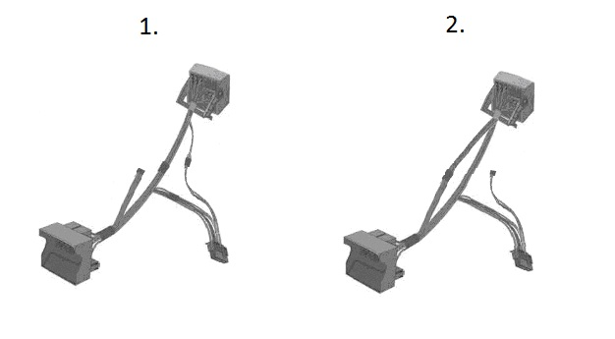
In the first case the 4pin Molex from the radio side quadlock connects to the 18pin Gateway side connector, so the radio uses the Gateway Pro as a phone module. In the second case the 4pin Molex from the radio side quadlock connects to the car side quadlock connector, so the radio uses the original phone module (if present). If the vehicle where the iGateway was installed, has a factory phone module, than you need to change the 4 pin Molex connector installation (from 1 to 2).

F. No sound from Navigation or phone (wires repopulation on BMW 17 PIN)

Sometimes on BMW the customers may complain that there is no sound when Navigation / phone is used. This might happen because the 10 pin Molex (white) connector (Dension piece) not all wires are present for the sound, therefore cannot be transferred to the speakers. In that case the installer needs to repin those wires in the harness in order to make it work properly.

G. Firmware update

Firmware update procedure on iGateway (earlier GW100) is much more complicated compare to other devices because of the missing USB option, which means iPod can be used for that only.

Please note: iPod touch and iPhone cannot be used for update

How to update:
- Delete all previous update files and reset your iPod
- Extract the attached ZIP archive
- Copy the update package to iPod via iTunes (approx. 750 files)
- Disconnect iPod from PC
- Turn the car radio on and change the source to Gateway (CD changer)
- Select Music/Genres/_config/GW_Menu/Update/Start_Update song and start playing it on your iPod
- While it’s playing, insert your iPod into the cradle or dock cable. (the update process will start automatically)
- After about 5 minutes, Gateway 100 will restart with the new firmware
- When the starting screen appeared on your iPod, you can check the version number in the top right corner of the screen
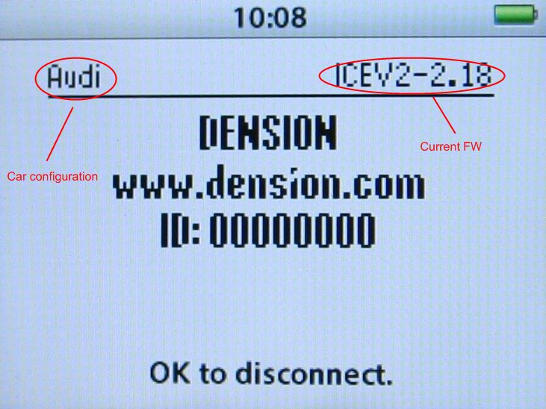
Please note:
The update process works only in Gateway User Interface mode (in which case the iPod's buttons are locked and control is only possible from the head unit).

This note also located in the update file in our website

H. Specific BMW issues (volume changing, CDC cannot be selected)

On BMW, it happens quite often that they forget to disconnect the original CD-Changer properly. If they do not use CDR (CD Retention kit – CDR2BM4) then, they have to disconnect all connectors physically at the CD-Changer (2 separate wires), otherwise they will experience strange issues like:

- Volume changing automatically / randomly within 10-15 seconds or more
- CD-Changer as a source can or cannot be selected but it reverts you back automatically to radio mode shortly (within 2-3 seconds)

I. Activation on VW (Volkswagen CAN BAP – GW17V21)

In case of CAN BAP based system (VW – GW17V21) the Media option is disabled on most cases therefore it has to be coded before or after the Gateway iGateway installation. The procedure is not difficult (takes 10 minutes approx.), the vehicle needs to be taken to the VW service and program the “Media Player 3” option (2E) by the service computer.

j. Volume is distorted or low compare to other sources

The iGateway has no USB port, therefore you need to use an iPod to change the volume output of the iGateway. You need to ask the installer / user to visit our homepage, especially the Knowledgebase or download section where the volume configuration files are located.

Briefly the procedure:

- Connect your iPod to the iGW100. Make sure you are in iPod GW (gateway) mode so that all controls are available via the Head Unit
- Disconnect your iPod and select the volume configuration file (can be 0.5, 1, 2 or 4 – use first two against from distortion) and press play
- Connect your iPod to the iGW100 (you have 1 minute left to start the procedure)
- The volume configuration procedure takes about 2 seconds. When finished, the next song will be audible on your car’s speakers
- Turn the Audio System OFF, remove the ignition key and wait about 20 seconds. Turn the Audio System back ON
- Test your Audio System. If the volume output is still distorted, please repeat steps 2-5 with the 0.5V volume configuration file

Please note:

- The volume changing method above does not work with iPod touch, iPhone (!)
- If the problem still persist, make sure that the customer tried in iPod GW mode. If yes: please recommend to use a different iPod and repeat these steps
- These volume configuration files working on iGateway only

Gateway Pro BT support issues

- iPod / iPhone / iPad compatibility
- iPod / iPhone is not recognized
- USB is not visible or does not work
- Phonebook content not visible
- There is no sound from iPod / iPhone and/or USB (BMW)
- Factory phone sound is not audible
- A2DP is not available
- CDC not removed properly (CD-Changer is there on iBus)
- Original phone is still there
- Activation on VW
- How to get GW_EES.BIN
- Volume issues
- Audi with different steering wheel buttons
- There is no Phone menu on Audi
- DIP switches

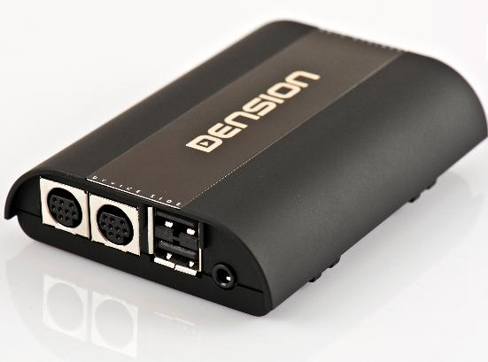

A. Gateway Pro BT iPod / iPhone / iPad compatibility

Supported iPod / iPhone devices via 30 PIN dock cable (not included in the package):

- iPod (4th generation)
- iPod nano (1st, 2nd, 3rd, 4th , 5th and 6 th gen.)
- iPod mini
- iPod Photo 4G
- iPod Video 5G
- iPod Classic (80/120/160GB)
- iPod Touch (1st, 2nd, 3rd and 4th generation)
- iPhone, iPhone 3G / 3 GS & iPhone 4 / 4S

Supported iPod / iPhone devices via “Lightning to USB cable” (not included in the package)
- iPod nano 7th generation
- iPod Touch 5th generation
- iPhone 5

iPad: iPad only works if iPod UI (Simple remote) mode is selected. Charging available on iPad 1st generation. Newer models require 2A of charging what we can’t provide.

B. iPod / iPhone not recognized

This usually happens if there is a problem with the iPod / iPhone or Dock cable. Before replacing anything, you need to try the following:
- Make sure that is has music on it
- Make a reboot (close all apps before if it is an iPhone)
- Update the iPod / iPhone if newer available
- Check the charging status. If there is no charging than the problem is bigger, might be installation related (no ground cable connected on VW / Audi)
- Test the system with different Apple product
- Disconnect and reconnect the hardware from the power
- Check the Dension website. There might be a specific update for the Gateway

C. USB compatibility

Flash Memory and Hard Disk Drive
File system: FAT16/32
Storage capacity: up to 320 GB music content
Music format: MP3, WMA and WAV

Please always recommend branded USB drives like Kingston, Sandisk, Transcend etc.

D. Phonebook content is not visible

Most cases if the problem persist you need to add a specific right to transfer those details to the HFP capable device (like the Gateway). This problem usually happens on Android based phones where after the successful 1st pairing you need to add that right in the specific hidden menu (slide down your finger from the TOP to get in like on iPhone).

If the problem still persists, delete pairing history, reboot the phone / gateway and repeat the procedure. If still no success, try to perform a FW update on the Gateway and phone and check the system with different cellphone if possible. Mail us also.

E. There is no sound from iPod / iPhone and/or USB

This problem could appear if

- The car has DSP (only BMW)
- The iPod Dock cable is not connected or wrongly connected (2nd port)

DSP: If the car has DSP, the application is not compatible, due to limitations of the Gateway device. DSP systems require a digital input but the Gateway provides analogue so in those cases there will be no sound, only control. Having a DSP option is rare, there is no label on the radio. You can tell if you check the Tuner. If you see a coax connector, then it must be a DSP based system.

iPod dock cable: On Gateway Pro BT, there are two 9 pin dock connector. One is dedicated to the iPod, 2nd one goes to the Connector port (if the installer / user ordered that piece separately).
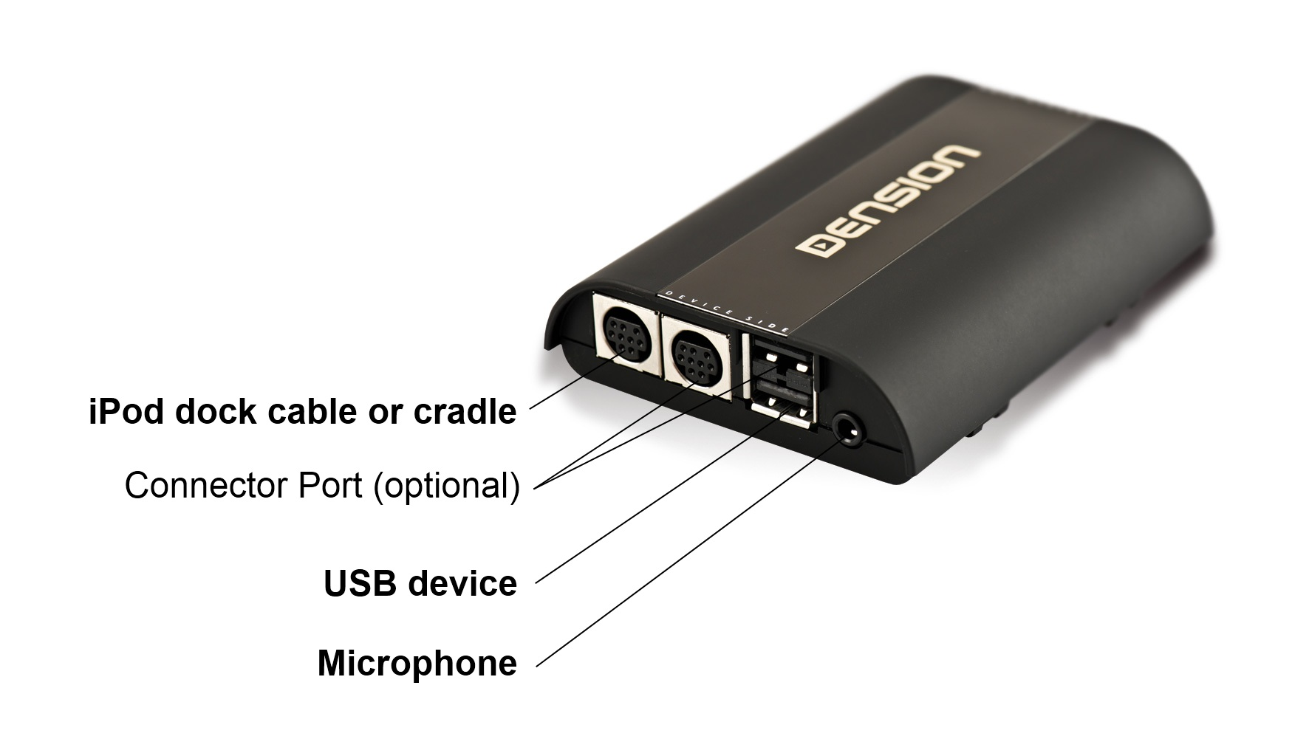
If the cable is connected to the wrong place than no sound will be audible and the iPod / iPhone device will not be recognized properly.
If you have no sound from USB and or iPod / iPhone too, than the problem might be related to the car harness, Gateway device the car specifications (DSP) or there is a conflict with another device (Like factory MDI). So please check the following:

- Installation
- Car specifications (DSP not supported)
- Make sure that there is no device which conflict with our module
- Check all sources (iPod / iPhone; USB) if possible to find out if the problem related to one source only

F. Factory phone option does not work

The Gateway Pro BT is capable to work as a Media player (Gateway functions are active only) or just a phone module (only on CAN BAP – GWP1V21). In order to turn a main function OFF (phone or media), you need to use the DIP switched on the hardware.

For disabling the phone part, DIP switch #5 needs to be turned ON.
For disabling the Media function on BAP, you need to turn the DIP switch #6 ON.
After changing the switches, you need to press reset on the device, in order to boot up with the new settings.

If the customer wants to use the Pro BT as a Media player, than he needs to

- Disable the phone option (DIP #5)
- Change the 4 PIN MOLEX (phone audio cable) installation on the Gateway harness. If you miss that step, the factory phone will work but w/o sound(!)

Please note: Factory phone and Phone option of the Gateway cannot be used together at the same time. One needs to be disabled / disconnected.

G. A2DP function is not available in the Source menu
The BT audio on Gateway Pro BT (500S BT too) is disabled by default therefore it needs to be turned ON in the Settings \ BT Audio menu on the Gateway.

The reason: most of our customers are using the Gateway Pro with iPhone. If BT audio is active and normal docking option is used with iPhone, than you might experience issues with the playback (does not start, no sound, no control….) which is an IOS bug however the users making complaints constantly, so we disabled by default in order to get less tickets.

The procedure of activation:

  - Go to the menu of the Gateway Pro BT. It is various how you need to do that e.g.
      - BMW: you need to press / select Disc 6
      - Audi: press menu button on the SWC
  - Select settings menu
  - Select BT Audio and Enter to that menu
  - set option OFF to ON and
  - SAVE (e.g. On BMW you need to press and hold the FFW button)
  - Turn the whole system OFF wait 1 or 2 minutes
  - Turn the system back ON -> now the phone will pair with BT audio option too
  - Go to the Source and select BT Audio

H. CDC not removed properly (CD-Changer is there on iBus)

On BMW, it happens quite often that they forget to disconnect the original CD-Changer properly. Please note: The installer needs to disconnect all cables physically at the CD-Changer (2 separate wires), otherwise they will experience strange issues like:

- Volume changing automatically / randomly within 10-15 seconds or more
- CD-Changer as a source can or cannot be selected but it reverts you back automatically to radio mode shortly (within 2-3 seconds)
- Functions buttons are not or partly working (e.g. FFW)
- They cannot enter to the Text selector menu

I. Original phone is connected

Those Gateway devices which have integrated phone options, does not work properly together with factory phone options. So it is not possible to use our device only for having BT Audio (A2DP) and use the factory option for HFP.

So in all cases, removing the factory phone is highly recommended or disabling the phone function on Gateway is required.

J. Activation on VW – Median and Phone (GWP1V21)

In case of CAN BAP based systems (VW – GWP1V21) the Media option is disabled (most cases) therefore it has to be coded before or after the Gateway installation.

The procedure is not difficult (takes 10 minutes approx.), the vehicle needs to be taken to the VW service and program the “Media Player 3” option (2E) by the service computer.

In order to have phone option too on the cluster display (MFA High Line is required) you need to program the phone options (77) to by using the Service computer, Autologic or VAG-COM. Having that option coded on RCD / RNS 310 are essential because on those radios the phone menu is available on the cluster display only!

K. How to get / generate the GW_EES.BIN file:
Getting a GW_EES.BIN file sometimes it is very useful because we can see
- what is the exact firmware version
- what are the basic settings (text, or car configuration)
- we can see if device is connected (like BTA1500)
The process of getting that file is very easy. You need to have a simple USB thumb drive which is
- formatted to FAT 16/32
- has only one partition
- there is one playable music content on it (it is no problem if other files are there too)
You need to do (ask from the customer / installer) the following
- Power the system ON (radio, ignition)
- Connect the USB to the Gateway (it will start flickering)
- Select the Gateway as a source
- Turn the whole system OFF, remove the car key too
- Wait about 1 or maximum 2 minutes then
- Turn the system ON again (e.g. radio)
- The USB will start flickering
- Wait 10 seconds, disconnect and check the content on a PC. The GW_EES.BIN should be on it
Please note: If the file is not available, then please ask them to use a different USB stick and repeat the mentioned steps above.
The firmware version can be checked if you open that file with WordPad. If you click on view, you will see the following:

In this case, the hardware has firmware version 3.00. Please check if there is newer firmware available for download. If yes: You need to always recommend that (!).

L. Volume issues

The default volumes what we set are based on our experiences on Gateway devices. Due to all efforts those levels are simply not good because the music is distorted or low compared to the other sources (radio, CD).

The Gateway Pro BT is a full text capable application including the menu browsing capability therefore without using any configuration files, you can set all volumes separately (!) from the Gateway menu.

You need to select the Gateway menu, then go to settings and select Volume menu option. If you enter that menu, you can browse between different options like

          - iPod
          - USB
          - AUX
          - Bluetooth (A2DP – BT Audio)
          - Phone and
          - Microphone (sensitivity)

The volume output will be changed as soon as you set the new volume level.

M. Audi with different steering wheel buttons

On certain Audi, the steering wheel controls can be different. If you have a customer if you have the following type as below, then you can recommend the Gateway Pro BT as a compatible system
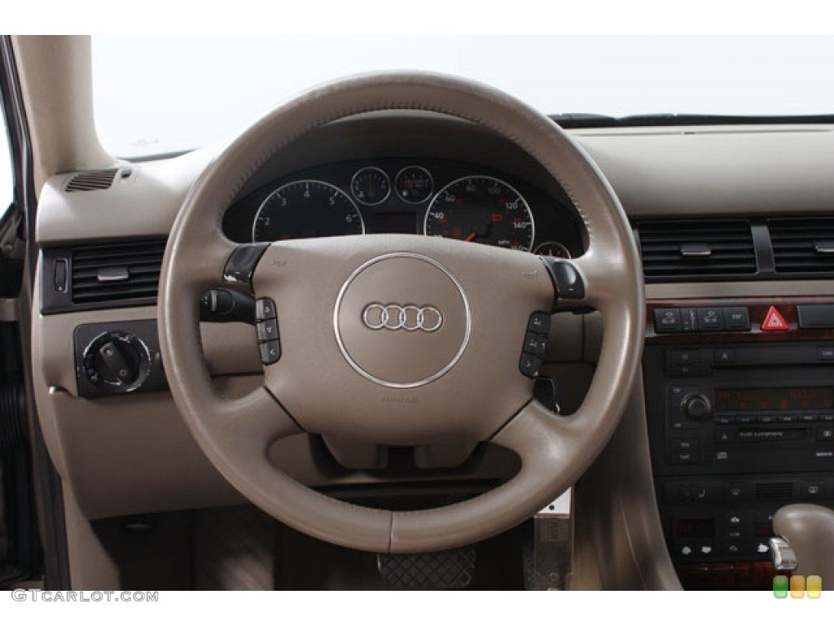
Please note: The controls are different and currently this info is missing in the manual.

right button:
- play view: enter menu
- menu view: next level of menu

left button:
- play view: toggle between play view and phone view
- menu view: up one level in the menu or if already in root, exit the menu

up button:
- play view: next song
- menu view: scroll menu up

down button:
- play view: previous song
- menu view: scroll menu down

N. There is no Phone menu on Audi

Sometimes, not so often, you might receive complaints regarding to missing phone menu. The symptom: Phone menu cannot be selected by pressing the ‘Menu’ button.

If you have the same issue above, please do the following

  - update the Gateway to 0045 at least
  - turn DIP switch #4 ON
  - Disconnect / Reconnect the Gateway from power or press reset
  - Test if the same issue present
  - If yes: Please let us know

O. DIP switches

There are 6 DIP switches on the Gateway Pro BT. The default settings are all OFF because car configuration are loaded from the Car harness (cable detect).

Gateway 500 (GW51MO2) support issues

- iPod / iPhone compatibility
- USB compatibility
- USB does not work
- Firmware update
- Alternator noise via AUX
- Volume issues
- Installation and programming issues
- GW51MBE issues

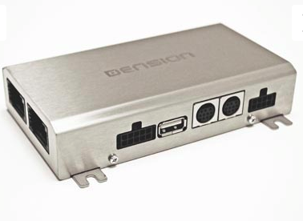

A. IPod / iPhone / iPad compatibility
It has the same compatibility as the Gateway Lite BT, so Lightning based Apple devices (iPhone 5, iPod touch 5th or nano 7th) can be used only with Lightning to 30 pin adapter.

Please note: Power booster is highly recommended (Dension Part: IPB1DIN) for newer iPhone and iPod touch devices (from iPhone 4 and touch 4th), because the old hardware could charge with 500mA by default.

iPad: iPad is works if iPod UI (Simple remote) mode is selected. Charging is available on iPad 1st. Newer models require 2A of charging what we can’t provide.

B. USB compatibility

Flash Memory and Hard Disk Drive
File system: FAT16/32
Storage capacity: up to 100 - 120 GB music content
Music format: MP3, WMA and WAV

Please always recommend branded USB drives like Kingston, Sandisk, Transcend etc.
Gateway indexer software is recommended for large music databases (from 4GB)

C. USB does not work:

You can try the same hints what I wrote earlier at Gateway Lite BT.

It is essential to check the following:

- USB meets with our requirements
- the file extensions (compression rate is not bigger than 320 kbps)
the system needs to be tested with different USB , where only 1-2 samples are present

D. Firmware update:

Works the exactly same way as on other devices like Gateway Lite BT or Gateway Pro.

The actual firmware version can be checked if you have the GW_EES.BIN. Just view it by using a WordPad. If you click on view, you will see the following:

Do not forget:

- File needs to be copied to the USB sticks root
- On that specific USB there must be at least one playable music content
- Use USB stick instead of HDD drive
- Do not disconnect the USB while the update is in progress (max. 2 minutes)
- Do not turn the engine ON while you are update (it can be turned ON before or after)
- Same version cannot be uploaded again

E. Alternator noise via AUX:

This problem is extremely rare but I’m writing it to you because it just appeared again a week ago. If you experience alternator noise, than the problem should be related to the power connection type.
In case of GW500 there are so many ways to get the power from (like the light from the glove box etc. which sometimes brings some additional noises). Our recommendation is to find a different constant power (which has a bigger wire which is shielded more) and ground.

F. Volume issues:

Having volume output issues with GW500 is rare. I had 2 cases in the last 4 years therefore we have not uploaded any volume configuration files to the Denison Site. If someone has a complaint, please contact us.

G: Installation / Programming issues:

Installing a GW500 is more difficult compare to Gateway Lite BT, iGateway or Pro BT. The main problem always the lack of the experience, knowledge of the installation. The most problematic parts are

- installation (how to, where to)
- enabling (especially on BMW, sometimes on Porsche too)

In case of the installation, please do not forget (!):

- Gateway must be the last connected device on the ring otherwise in active mode other devices like: Amplifier, Phone, Navigation or something else won’t be accessible
- If factory CDC available, please always install beside the factory CD-Changer
- Please double check always the light directions on the MOST cable
- Power needs to be constant / permanent 12V. Especially on BMW, you need to be careful because 2 different kinds of switched power available. 1st goes OFF immediately as soon as you remove the car key, the 2nd goes OFF after 15 minutes (!)
- Set the proper DIP setting. If you change the DIP, please always press the reset or disconnect from the power a little bit

In case of the enabling, please keep in your mind the following:

- The Gateway 500 emulates a CD-Changer (in most cases, expect BMW where it is operate as a iPod device) therefore that option in certain vehicles needs to be programmed like:
        - BMW
        - Mercedes (sometimes)
        - Porsche
        - Saab

- Sometimes the vehicle needs to have Factory CD-Changer otherwise the GW500 won’t work
        - Mini
        - Volvo

- Sometimes the CD-Changer needs to be physically installed while you program the CDC option
        - Saab (it can be front or Rear)

The enabling procedure can be done by the official Service computer, however there are other alternative too. We recommend using Autologic instead of the BMW programmer, because

- There is a separate coding menu on the enabler specifically for Dension Gateway installation
- You don’t need to update the vehicle’s software to add / remove a function. At the BMW, you need to always have the latest software. The programming therefore could take 7-8 hrs (!!!!) at BMW. At Autologic, in the worst scenario this take 10 minutes.
- It is cheaper: ~40-70 dollars with Autologic, 120-160 dollar with BMW
- We have a complete guide, how to do (!)
- The service managers at BMW have no enough experience

The table below summarizes all possible ways of installing the GW500 in BMW models.
(Please note: This description is valid only for iDrive 3 Audio Systems non for iDrive 4)

BMW with ”i-Drive 3” (non-iDrive Professional, M-ASK / Business and CCC / Prof.)

Options | E65¹ before 03/2005 | E60² M-ASK | All other models
original CD changer fitted and MP3 capability³ is already available | not possible combination⁴ | convert CD Changer option to „IPOD” retrofit⁵ | no programming required
original CD changer fitted and no MP3 capability is available, text capable BMW mode is used |  |  | retrofit “KMP3” option with service computer
original CD changer fitted and no MP3 capability is available, non text capable BMW mode is used | no programming required
original CD changer not fitted | use BMW non-text DIP switch setting and retrofit CD Changer | retrofit “IPOD” option with service computer

Important note:

- If the SW of the car requires an update or a KMP3 activation, switch the Gateway to bypass/service mode before you start the procedure. Before converting or retrofitting IPOD option, switch back to GW mode.

¹ - E65 means all 7 series model variations (E65/E66)
² - E60 means all 5 and 6 series model variations (E60/E61/E63/E64)
³ -the car is MP3 capable if the front CD-Slot reads MP3 audio discs and the ID3 tags are visible on the display
⁴ - In case of E65 there was a Head Unit hardware change in 03/2005. Cars which were produced before this date cannot be enabled for MP3, therefore text capability will not be available with the Gateway
⁵ - M-ASK system without Navigation works only in non-text mode, therefore converting option is not necessary

After the installation the device still does not work:

- Make sure the AUX box switch is in the full circle mode and not Bypass
- Check the DIP switch settings
- Check the light directions
- Check the Blue LED status on the AUX-Box

LED symptoms:

- LED is Solid -> Gateway is powered and booted properly
- LED is flashing quickly than it goes OFF -> There is a brake on MOST ring. Check install
- LED is flashing slowly constantly -> Bypass mode selected
- LED is OFF -> No Power. Check install and the fuse on the power cable
- LED is flickering quickly before it goes solid at each time ->Gateway connected to the switched power –>In that case the Gateway will start to operate in AUX GW mode

Brand Specific issues:

BMW:

- Check if the vehicle has a CD Changer, if not this will have to be activated at a dealership
- Check the MOST service for loop. Dealers sometimes miss this off if there are no other modules in the vehicle. (Under glove box flap)

Specific Symptoms:

  - The CD changer is active but all grey on the iDrive

  - Check the dip switches are correct. 1,2 for TEXT and just 2 for no TEXT vehicles
  - On M-ASK (Business – smaller screen) it is not enough if the vehicle has KMP3 (front single CD reads mp3 disc) function, the GW500 needs to be installed as an iPod device (iPod retrofit). If the vehicle has CDC, that the CD-Changer option needs to be concerted to iPod. See above the detailed activation quide
  - On CCC professional you need to activate KMP3 mode

  - I got no text on my display

- Check the unit is in Gateway mode
- Check for KMP3 compatibility on CCC Professional
- Check the DIP switch settings and make sure TEXT mode is selected
Mercedes:

- Check compatibility no NTG2.5 or 4
- Check if the vehicle has a CD Changer, or an active loop, if not this will have to be activated at a dealership.

Specific Symptom:

  - I got no text on my display

- Check the unit is a Comand radio
- Check the device is in iPod Gateway mode
- Text activation will be required

Aston Martin / Volvo:

- Check if the vehicle has a CD-Changer without AUX-in
- Make sure it is installed at the CD-Changer (2A in the guide)

Specific Symptom:

  - I got errors on the screen when I power up

- The Gateway 500 is installed incorrectly ( Not a CD-Changer)
- The fibers are incorrect
- Wrong compatibility (year, has AUX or no CDC etc.)

  - I got no text on my display

- Check the unit is in Gateway mode
- RCD text and MP3 text will have to be turned on the Head Unit menu

H: GW51MBE issues:

The Gateway 500 GEN enabler edition is more or less the same device as the Gateway 500 (GW51MO2). The differences are

  - It has single FOT optical connector (CDC cannot be retained)
  - Designed for BMW (works on other vehicles too w/o GEN of course)
  - It is compatible with all BMW, except 7 series (!)
  - Comes with the GEN enabler tool

Before you start, please make sure:
  - The ignition is ON
  - The proper DIP settings is selected on the Gateway (do not use non-text setting – 2,6 ON – of the GW500)

If there is a problem at the end (LED is RED on the GEN)
  - Check if the ignition was ON
  - Make sure that the proper DIP settings were set
  - The DIP switches on the GEN has not been changed (all of them needs to be turned OFF)
  - Check if the OBD connector has no extra Anti-theft protection

If the problem still persists, the only option what is left is to send a log file from the GEN.

How to get a log file from GEN:

- Change the DIP switch settings on GEN. For Maintenance mode DIP switch #1 must be turned ON
- Connect the GEN to your PC via Mini USB cable
- The windows will recognize it but correct drivers will be missing, therefore please give the access root on widows to the GEN ‘Driver’ directory
- After the successful recognition / installation Run ‘DfuSeDemo.exe’ file from the ‘Programmer’ directory

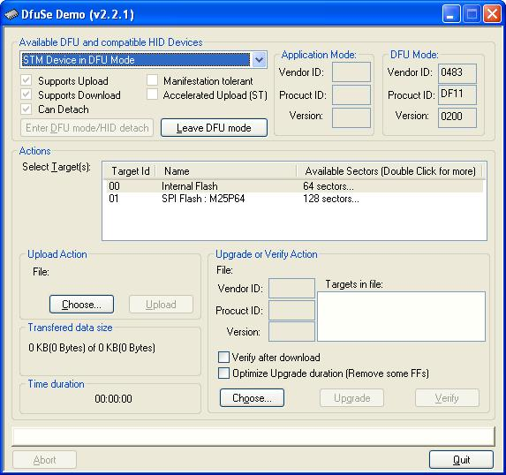

- Go to ‘Upload Action’ and select ‘Choose’
- On the pop-up screen give a title / name for the file
- Select ‘Upload’ at ‘Upload Action’

- On the next pop-up screen press ‘Yes’ to save the log file

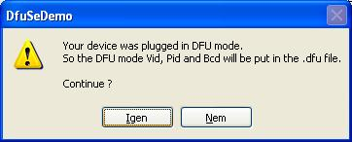

- The file will be saved to the same directory (Programmer)
- Send us the requested log file

PC requirements:
----------------
Software:

- 32-bit of Microsoft Windows® XP (64-bit not supported)
- 32-bit editions of Microsoft Windows® Vista (64-bit not supported)
- 32-bit editions of Microsoft Windows® 7 (64-bit not supported)

Plus you will need a mini USB cable for connecting your GEN to your PC

Please note: you must send the appropriate installation files to the customer / installer for the successful GEN recognition via USB.

The GEN file needs to be sent by you to us. Approximately it requires a day at least to check the content and decode the result of the programming.

Gateway 500S BT (GW52MO2) support issues

- Differences between the GW500 and GW500S BT
- iPod / iPhone compatibility
- USB compatibility
- USB does not work
- Firmware update
- Volume issues
- Installation and programming issues
- Phone issues
- Places of the factory CDC and Phone

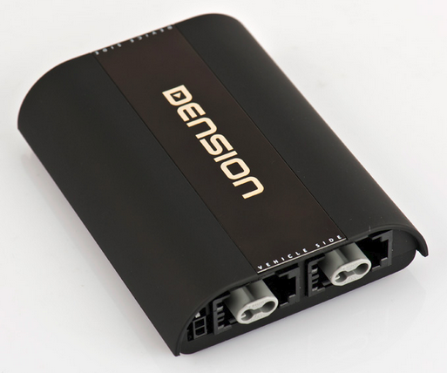

A. Differerences between the GW500 (GW51MO2) and the GW500S BT (GW52MO2)

- Gateway 500S BT has a Built-in Bluetooth (HFP + A2DP) option
- Gateway 500S BT is compatible with cars where TEXT display is possible
- Gateway 500S BT is capable to charge by 1A (no power booster required)

 | GW500 (GW51MO2) | GW500S BT  (GW52MO1) or (GW52MO2)
Text | Yes, but works with non-text capable systems too  e.g. CDR23, Audio 20 | Yes, but non-text capable systems are not supported  e.g. Mercedes Audio 20/50
Retains factory CDC | Yes | Yes but only the Dual FOT  (GW52MO2) version
USB Lightning support | No | Yes
2nd USB socket for additional charging | No | Yes
Bluetooth | Not available anymore | Integrated
1A charging support | Power Booster required | Yes

Compatibility differences:

The old Gateway 500 supports the following applications (GW500S BT does not):

- Aston Martin DB9
- BMW 7 series (E65/E66)
- Mercedes with Audio 20/50 or Comand with END/SEND buttons
- Rolls-Royce Phantom
- Porsche with CDR23/24
- Volvo S40/V50 and XC90
- Saab 9-3 and 9-5

B. Gateway Pro BT iPod / iPhone \ iPad compatibility

Supported iPod / iPhone devices via 30 PIN dock cable (included in the package):

- iPod (4th generation)
- iPod nano (1st, 2nd, 3rd, 4th , 5th and 6 th gen.)
- iPod mini
- iPod Photo 4G
- iPod Video 5G
- iPod Classic (80/120/160GB)
- iPod Touch (1st, 2nd, 3rd and 4th generation)
- iPhone, iPhone 3G / 3 GS & iPhone 4 / 4S

Supported iPod / iPhone devices via “Lightning to USB cable” (not included in the package)
- iPod nano 7th generation
- iPod Touch 5th generation
- iPhone 5

iPad: iPad is only works if iPod UI (Simple remote) mode is selected. Charging available on iPad 1st generation. Newer models require 2A of charging what we can’t provide.

C. USB compatibility

Flash Memory and Hard Disk Drive
File system: FAT16/32
Storage capacity: up to 320 GB music content
Music format: MP3, WMA and WAV

Please always recommend branded USB drives like Kingston, Sandisk, and Transcend etc.
Gateway indexer software is recommended for large music databases (from 4GB)

D. USB does not work:

You can try the same hints what I wrote at Gateway Lite BT.

It is always important to check the following:

- USB meets with our requirements
- The file extensions (compression rate is not bigger than 320 kbps)
The system needs to be tested with different USB, where only 1-2 samples are present

E. Firmware update:

Works the exactly same way as on other devices like Gateway Lite BT or Gateway Pro.

The actual firmware version can be checked if you have the GW_EES.BIN . Just view it by using a WordPad. If you click on view, you will see the following:

Do not forget:

- File needs to be copied to the USB sticks root
- On that specific USB there must be at least one playable music content
- Use USB stick instead of HDD drive
- Do not disconnect the USB while the update is in progress (max. 2 minutes)
- Do not turn the engine ON while you are update (it can be turned ON before or after)
- Same version cannot be uploaded again

F. Volume issues

The default volumes what we set are based on our experiences on Gateway devices. Due to all effort those levels are simply not good because the music is distorted or low compared to the other sources (radio, cd).

The Gateway Pro BT is a full text capable application including the menu browsing capability therefore without using any configuration files, you can set all volumes separately (!) from the Gateway menu.

You need to select the Gateway menu, then go to settings and select Volume menu option. If you enter that menu, you can browse between different options like

          - iPod
          - USB
          - AUX
          - Bluetooth (A2DP – BT Audio)
          - Phone and
          - Microphone (sensitivity)

The volume output will be changed as soon as you set the new volume level

G. Installation / Programming issues:

You can have the exactly same programming issues what I wrote earlier at Gateway 500 (GW51MO2) however, do not forget, GW500S BT comes with phone option too which could cause “troubles”.

Please do not forget the following facts:

- The Gateway 500S BT works only on TEXT capable systems
- The phone needs to be programmed on BMW only (!) . Luckily the phone works without any additional procedure on Audi, Mercedes (right now only with EU spec. radio where no END / SEND button available) and Porsche
- If the vehicle has factory phone -> It needs to be removed because the phone part of the GW500S does not works as a standalone BT audio option, so there will be a conflict between the Dension piece and the factory

For Programming recommend Autologic as an option.

H: Places of the factory CD-Changers and Factory phones:

Phone:

Audi A6/A8 -> behind the carpet at the Driver’s seat
Porsche -> behind the passenger’s seat

CD-Changer:

Mercedes S / SL -> in the trunk
Porsche -> in the trunk

Gateway 500 Lite support issues

- Differences between the GW500 and GW500 Lite
- iPod / iPhone compatibility
- USB compatibility
- USB does not work
- Firmware update
- Installation and programming issues

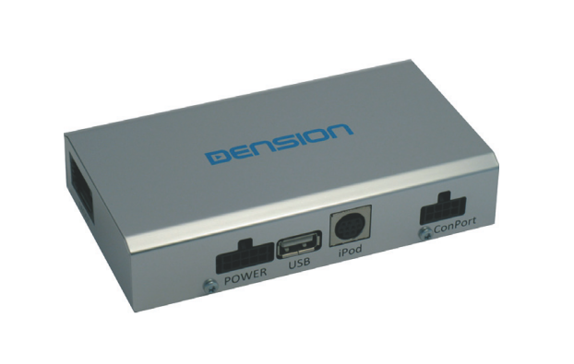

A. Differerences between the GW500 (GW51MO2) and the GW500S BT (GW52MO2)

- Gateway 500 Lite is designed for cars where non-text display is possible
- It has only one single FOT connector, so retaining the CDC is not possible
- There is no AUX-BOX in the package
- Lite have no DIP switches, therefore configuration via USB is required (Mercdes default)
- The iPod dock cable is not the part of the package

B. IPod / iPhone / iPad compatibility

It has the same compatibility as the Gateway Lite BT, so Lightning based Apple devices (iPhone 5, iPod touch 5th or nano 7th) can be used only with Lightning to 30 pin adapter.

Please note: Power booster is highly recommended (Dension Part: IPB1DIN) for newer iPhone and iPod touch devices (from iPhone 4 and touch 4th), because the old hardware could charge with 500mA by default.

iPad: iPad is works if iPod UI (Simple remote) mode is selected. Charging is available on iPad 1st. Newer models require 2A of charging what we can’t provide.

C. USB compatibility

Flash Memory and Hard Disk Drive
File system: FAT16/32
Storage capacity: up to 100 GB music content
Music format: MP3, WMA and WAV

Please always recommend branded USB drives like Kingston, Sandisk, Transcend etc.
Gateway indexer software is recommended for large music databases (from 4GB)

D. USB does not work:

You can try the same hints what I wrote at Gateway Lite BT.

It is always important to check the following:

- USB meets with our requirements
- The file extensions (compression rate is not bigger than 320 kbps)
- The system needs to be tested with different USB , where only 1-2 samples are present
- Use Gateway indexer

E. Firmware update:

Works the exactly same way as on other devices like Gateway Lite BT or Gateway Pro.

The actual firmware version can be checked if you have the GW_EES.BIN . Just view it by using a WordPad. If you click on view, you will see the following:

Do not forget:

- File needs to be copied to the USB sticks root
- On that specific USB there must be at least one playable music content
- Use USB stick instead of HDD drive
- Do not disconnect the USB while the update is in progress (max. 2 minutes)
- Do not turn the engine ON while you are update (it can be turned ON before or after)
- Same version cannot be uploaded again

G. Installation / Programming issues:

In case of the installation, please do not forget (!):

- Gateway must be the last connected device on the ring otherwise in active mode other devices like: Amplifier, Phone, Navigation or something else won’t be accessible
- Factory CD-Changer cannot be retained
- Programming required if there is no factory CD-Changer available on BMW, Mercedes, Porsche and Saab
- Please double check always the light directions on the MOST cable
- Power needs to be constant / permanent 12V. Especially on BMW, you need to be careful because 2 different kinds of switched power available. 1st goes OFF immediately as soon as you remove the car key, the 2nd goes of after 15 minutes (!)
- There is no DIP switches, therefore it requires an additional USB configuration (Mercedes set to default)

For Programming we recommend the Autologic as an option.

Gateway 500 Lite D2B support issues

- Differences between the MOST and D2B Lite
- iPod / iPhone compatibility
- USB compatibility
- USB does not work
- Firmware update
- Installation and programming issues

A. Differences between D2B and MOST

D2B was made by Mercedes and was available in vehicles like Mercedes or Jaguar. We have only compatible part for Mercedes (GWL1DB1). For Jaguar only OEM (factory) solution is available. The cables are the same (fiber) the differences is the optical network and the connectors at the end.

B. IPod / iPhone / iPad compatibility

It has the same compatibility as the Gateway Lite BT, so Lightning based Apple devices (iPhone 5, iPod touch 5th or nano 7th) can be used only with Lightning to 30 pin adapter.

Please note: Power booster is highly recommended (Dension Part: IPB0DIN) for newer iPhone and iPod touch devices (from iPhone 4 and touch 4th), because the old hardware could charge with 500mA by default.

iPad: iPad is works if iPod UI (Simple remote) mode is selected. Charging is available on iPad 1st. Newer models require 2A of charging what we can’t provide.

C. USB compatibility

Flash Memory and Hard Disk Drive
File system: FAT16/32
Storage capacity: up to 100 GB music content
Music format: MP3, WMA and WAV

Please always recommend branded USB drives like Kingston, Sandisk, Transcend etc.
Gateway indexer software is recommended for large music databases (from 4GB)

D. USB does not work:

You can try the same hints what I wrote at Gateway Lite BT.

It is always important to check the following:

- USB meets with our requirements
- The file extensions (compression rate is not bigger than 320 kbps)
- The system needs to be tested with different USB , where only 1-2 samples are present
- Use Gateway indexer

E. Firmware update:

Works the exactly same way as on other devices like Gateway Lite BT or Gateway Pro.

The actual firmware version can be checked if you have the GW_EES.BIN . Just view it by using a WordPad. If you click on view, you will see the following:

Do not forget:

- File needs to be copied to the USB sticks root
- On that specific USB there must be at least one playable music content
- Use USB stick instead of HDD drive
- Do not disconnect the USB while the update is in progress (max. 2 minutes)
- Do not turn the engine ON while you are update (it can be turned ON before or after)
- Same version cannot be uploaded again

G. Installation issues:
In case of the installation, please do not forget (!):

- Factory CD-Changer cannot be retained. If available it needs to be looped
- Programming required if there were no device on the optical network earlier
- Wake up wire needs to be connected properly according to the manual

Specific Symptom:

  - The radio does not see the connected Gateway device

- The radio was not coded / programmed for CDC
- The wake up wire is not or connected to the wrong pin
- The CD-Changer was not looped properly so the there is a brake on the ring
- There is a problem with the optical cable –> try the another one in the package

  - Worked fine for long but suddenly my radio does not see it anymore

- Update or downgrade the firmware (it reboots automatically the device)
- Disconnect or reconnect from power and test

  - Does not see or does not charge the connected iPod

- Reboot the iPhone or iPod touch
- Test the iPod connection with different iPod

